**POC FOR ASSIGNMENT-6**

LINK - <https://ap-south-2.console.aws.amazon.com/lambda/home?region=ap-south-2#/functions/MayankS3Lambda?tab=code>

Code ->

import boto3

def lambda_handler(event, context):

**# Specific source bucket name and Destination Bucket Name and also specific s3 region**

source_bucket = 'src-s3lambda'

destination_bucket = 'dest-s3lambda'

source_region = 'us-east-1' **#us-east-1 is the bucket region**

# Create an S3 client with the specified region

s3 = boto3.client('s3', region_name=source_region)

**# List all objects in the source bucket**

try:

**#this response will get the content of all folder where / is used to specific folder name “folder-name/”**

response = s3.list_objects_v2(Bucket=source_bucket, Prefix='', Delimiter='/')

objects = response.get('Contents', [])

for common_prefix in response.get('CommonPrefixes', []):

prefix = common_prefix['Prefix']

**#this object will get the individual contents in the folder**

objects.extend(s3.list_objects_v2(Bucket=source_bucket, Prefix=prefix).get('Contents', []))

except Exception as e:

print(f"Error listing objects in {source_bucket}: {e}")

raise # Re-raise the exception to propagate it to CloudWatch Logs

**# Iterate over each object and copy it to the destination bucket**

for obj in objects:

key = obj['Key']

copy_source = {'Bucket': source_bucket, 'Key': key}

destination_key = key # Optionally, you can modify this to place objects in a specific folder

destination = {'Bucket': destination_bucket, 'Key': destination_key}

**#copy the all content from source to destination bucket**

try:

s3.copy_object(CopySource=copy_source, Bucket=destination['Bucket'], Key=destination['Key'])

print(f"Successfully transferred {key} from {source_bucket} to {destination_bucket}")

except Exception as e:

print(f"Error transferring {key}: {e}")

return {

'statusCode': 200,

'body': 'Transfer completed successfully'

}

If the code gives timeout increase the time in configuration of lambda function

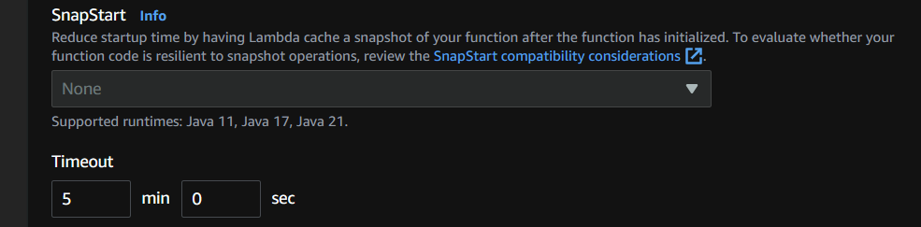

**Screenshot - >**

* 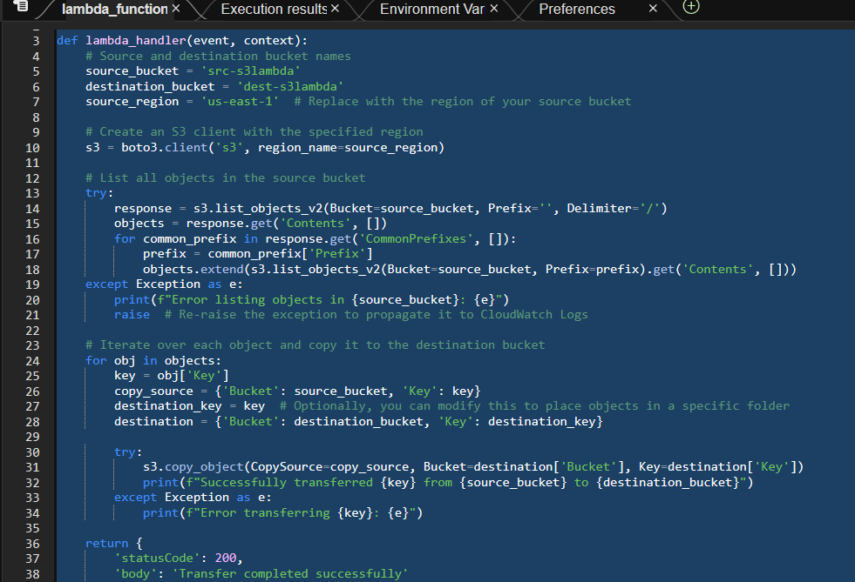After coding click on deploy and test the code.

Output

